Practical No:1

Aim: Write a simple javascript with HTML for arithmatic expression evaluation.

Theory:

-methods for message printing:

….

…..

….

-Expression(operator):……… -Types of oprator in javascript:………….

Program:

…..

…..

……

Output:

Practical Related Questions:

Batch 1:

What is bitwise operator ?explain with example Describe conditional operator?

Batch2:

Explain Assignment operator with example What is expression?

Batch 3:

Explain the relational operators with example What is use of getElementByid()?

Exercise:

Pgm1: WAP to print table of given no.

Pgm2:WAP to find a greater number between 3 nos

Pgm3:WAP to check given no is even or odd

Conclusion:

In this practical I have studied how to evaluate a expression by using different types of operators.

Practical No :2 Aim:…….

Theory:

………Decision Making stmts:

-def

-List

-explain one of them Looping stmts:

-def

-list

-explain one of them

……

…..

…..

Program:

1.Decision making:

2.Looping stmt:

Output:

Practical related Q:

1.Compare while and do-while loop

2.Explain if-else stmt Batch 2:

1.Explain for loop with syntax

2.Give syntax of switch case Batch 3:

1.Explain nested if else with syntax

2.Diff bet for and for in loop

Exercise:

Pgm1:

WAP to print factorial of nos Pgm2:

WAP to check whether given no is positive or negative Pgm3:

WAP to print odd no between 1 to 30

Coclusion:

Here we have studid……..

Practical no:3

Aim: Implement array functionalities Theory:

-Array:

-Declaration:

-Defining array elements:

-Different methods of array:

Program:

Output:

Pr.r.q:

1)compare search() and match() of string

2)how you can add elements to array Batch2:

1)Explain use of length keyword with example

2) Explain purpose of substr() and substring() Batch 3:

1) how to combine array elements into string?

2)How to sort elements in array?

Exercise:

1)WAP to display 5 elements of array in sorted order and reverse order

2)WAP to find highest and lowest number from array 3)WAP to extract the third and the fourth elements from the array(take any array of 6 elements) Conclusion:

In this practical we have studid….

Practical NO:4

Aim: Develop javascript to implement functions Theory:

-Function Definition and syntax

-defining function Program:

Output:

Pr.r.Q:

Batch 1:

1)How to call a function with argument.Write example?

2)How to call a function from html?

Batch2:

1) Diff bet Global variable and local variable

2)what is use of onload and onunload attribute? Batch3:

1)how to add multiple arguments to function.

2)How to invoke function as a method?

Exercise:

Batch -1) Write a JavaScript function that reverse a number.

Batch-2) Write a JavaScript function that accepts a number as a parameter and check the number is prime or not

Batch -3) Write a JavaScript function that finds a square root of a number Conclusion:

In this practical we have studid….

Practical no:5

Aim:

Devlop javascript to implement strings Theory:

String def,declaration,defination Program:

..

Output:

…

Pr.r.Q:

1)How to retrieve a character from given position?

2)write use of concat() with example

1)what is Purpose of split().Explain with exampleCa 2)How to retrieve position of character?

1)Write use Substring() with example 2)How to convert string to number?

Exercise:

1. Write a JavaScript function that accepts a string as a parameter and counts the number of vowels within the string
2. Write a JavaScript function that returns a passed string with letters in alphabetical order.
3. WAP that demonstrate string replace() method

Conclusion:

In this practical we have studid….

Practical 6:

Aim:Create a webage using form elements

Theory:

-List all Form elements

-Explain 5 elements

Program:

Output:

Q:

1)Mention use of <form> element

2) Explain use of action attribute with example

1) Explain use of target attribute with example

2)how would you display checkbox on form?

1) how would you display image on form?

2) Explain use of method attribute with example

Exercise:

WAP to display

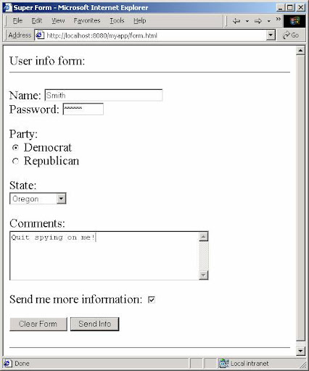

2)WAP to display

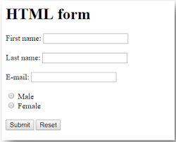

3)WAP To display: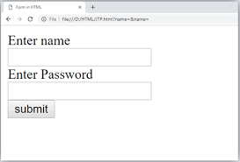

Practical No:7

Aim:

Theory:

-Mouse events

-form events

Program:

Output:

Pr.R.Q:  
1) how you achieve blur event of form.

2)Explain mouseover and mouseout event with example

1)Elaborate Change and submit event of form.

2)How could you use oncontextmenu event

1)Explain focus and blur events of form

2) how you achieve click event of mouse.

Exercise:

1)WAP that demonstrate Mouseover and Mouseout event

2)WAP that demonstrate Focus and blur event of form.

3)WAP that demonstrate Click and contextmenu event

Practical No:8

Aim:

Theory:

-Key events

-document/window events

Program:

Output:

Pr.R.Q:  
1) How you achieve keydown event.

2) Explain load event of window with example.

1) Elaborate unload event of window.

2) How could you use keypress event.

1) Mention necessity of keyboard events.

2) How you achieve keyupevent.

Exercise:

1) WAP that demonstrate load and unload event

2) WAP that demonstrate keyup and keydown event

3) WAP that demonstrate keypress event

Practical No:9

Aim:

Theory:

-Intrinsic function explanation

-javascript built-in objects

Program:

Output:

Pr.R.Q:

## Explain use of isNaN() with example.

1) **Write a JavaScript function to insert a string within a string at a particular position**